**CSCE 5300: Introduction to Big data & Data science**

**Assignment 3**

**Name: PERUMALLA SRINU**

**ID:11750704**

**CSCE_5300**

**Apache Cassandra:**

**1**. **Database Design and Schema Creation for the social media application:**

**FACEBOOK**

**Creating facebook keyspace:**

* This query creates a keyspace named "facebook" using SimpleStrategy with a replication factor of 1, meaning that there will be only one copy of each data item:



**Creating Tables:**

**1.USERS TABLE:**

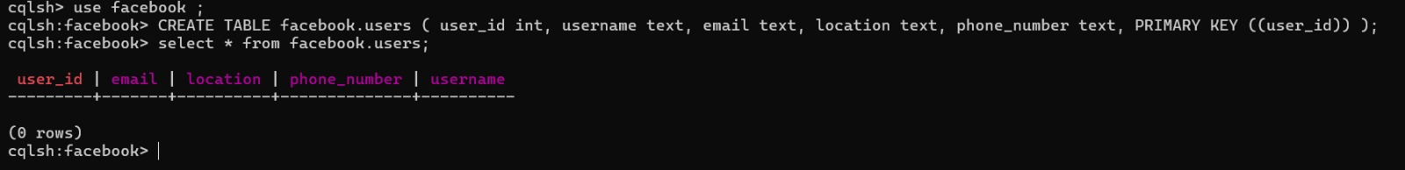

* **Partition Key**: **user_id** is chosen as the partition key as it provides a unique identifier for each user and evenly distributes data across nodes.
* This table is designed to store basic user information, and the primary key **user_id** uniquely identifies each user. Since the queries mentioned don't involve range queries on user attributes, no clustering columns or secondary indexes are necessary.

**2.POSTS TABLE:**



* **Partition Key:** **user_id** is chosen as the partition key as it provides a unique identifier for each user and evenly distributes data across nodes.
* **Clustering Columns: post_id** is chosen as the clustering key as it provides to uniquely identify each post within a user posts
* This table is designed to store posts made by users. Grouping by **user_id** allows for efficient retrieval of all posts by a user. The clustering column **post_id** ensures each post is uniquely identified within a user's posts.

**3.COMMENTS TABLE:**



* **Partition Key:** **post_id** (to group comments by post)
* **Clustering Columns:** **comment_id** (to uniquely identify each comment within a post)
* This table is designed to store comments on posts. Grouping by **post_id** allows for efficient retrieval of all comments on a post. The clustering column **comment_id** ensures each comment is uniquely identified within a post's comments.
* Choosing the appropriate partition key is crucial for efficient data distribution and query performance. It should be based on the most frequent access patterns of your application.
* Clustering keys determine the sorting order of data within a partition. Selecting the right clustering keys can significantly improve query performance

**2.Data Modeling and Population:**

* Populate the Cassandra database with sample data.
* By using **FAKER** library I am Generated the synthetic data

**USERS TABLE:**

* using faker library I am Generate synthetic data for **facebook.users** database schema.

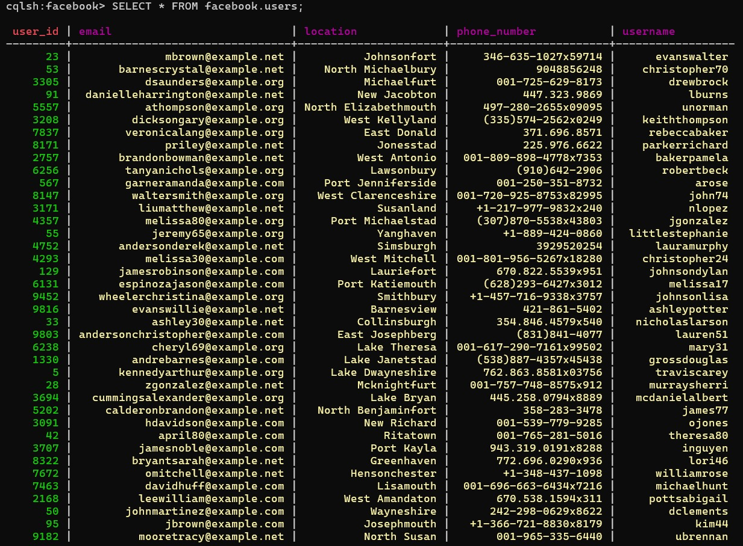

**POSTS TABLE:**

* using faker library I am Generate synthetic data for **facebook.posts** database schema.

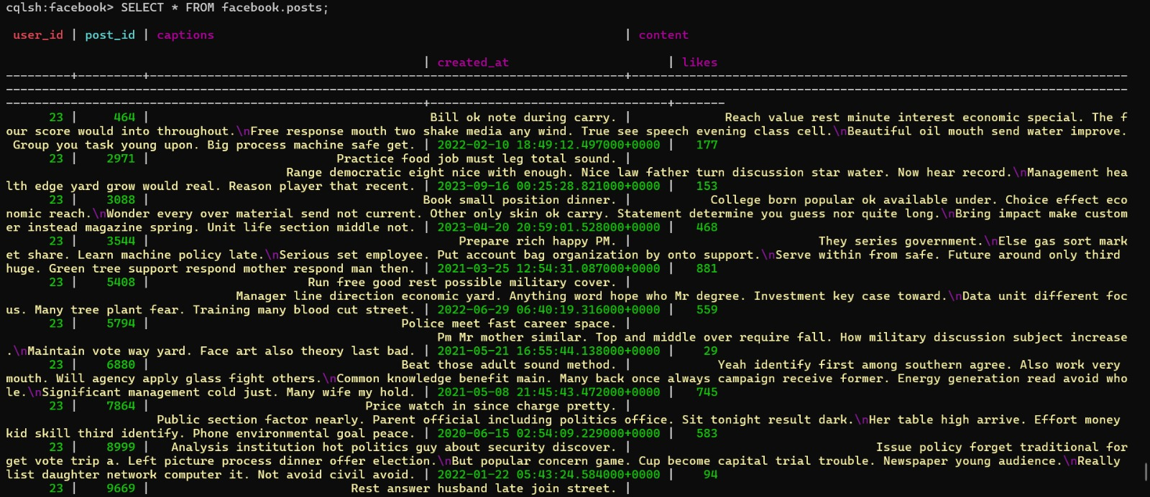

**COMMENTS TABLE:**

* using faker library I am Generate synthetic data for **facebook.comments** database schema.

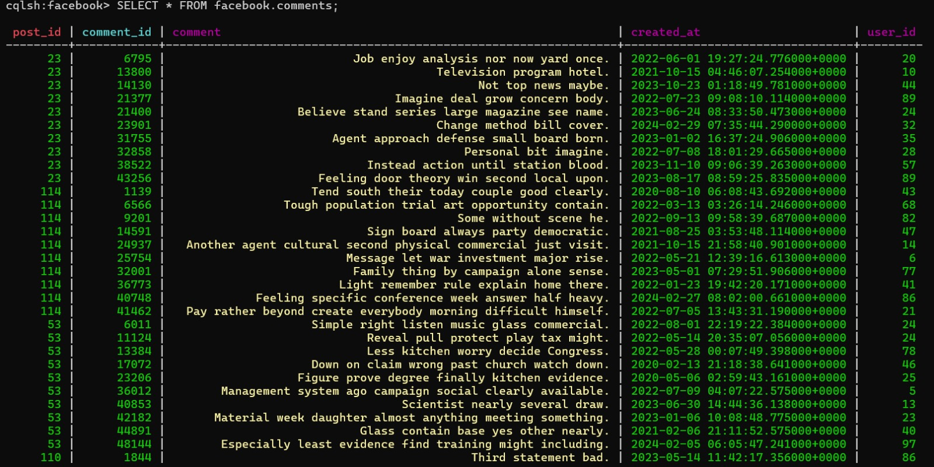

**CREATING DENORMALISED TABLE:**



**For the facebook.d_posts table:**

* **Partition Key:** **user_id** is used as the partition key to distribute data evenly across nodes and allow efficient retrieval of posts for a specific user.
* **Clustering Key:** **post_id** is used as the clustering key to maintain the order of posts within each user's partition.
* **Secondary Indexes:** Secondary indexes on **username, created_at, likes,** and **captions** are used to support common query patterns for retrieving posts based on these criteria.
* These design decisions align with the use case scenario by providing efficient retrieval of posts for a specific user and supporting common query patterns for post retrieval.

**d_posts Denormalized table:**

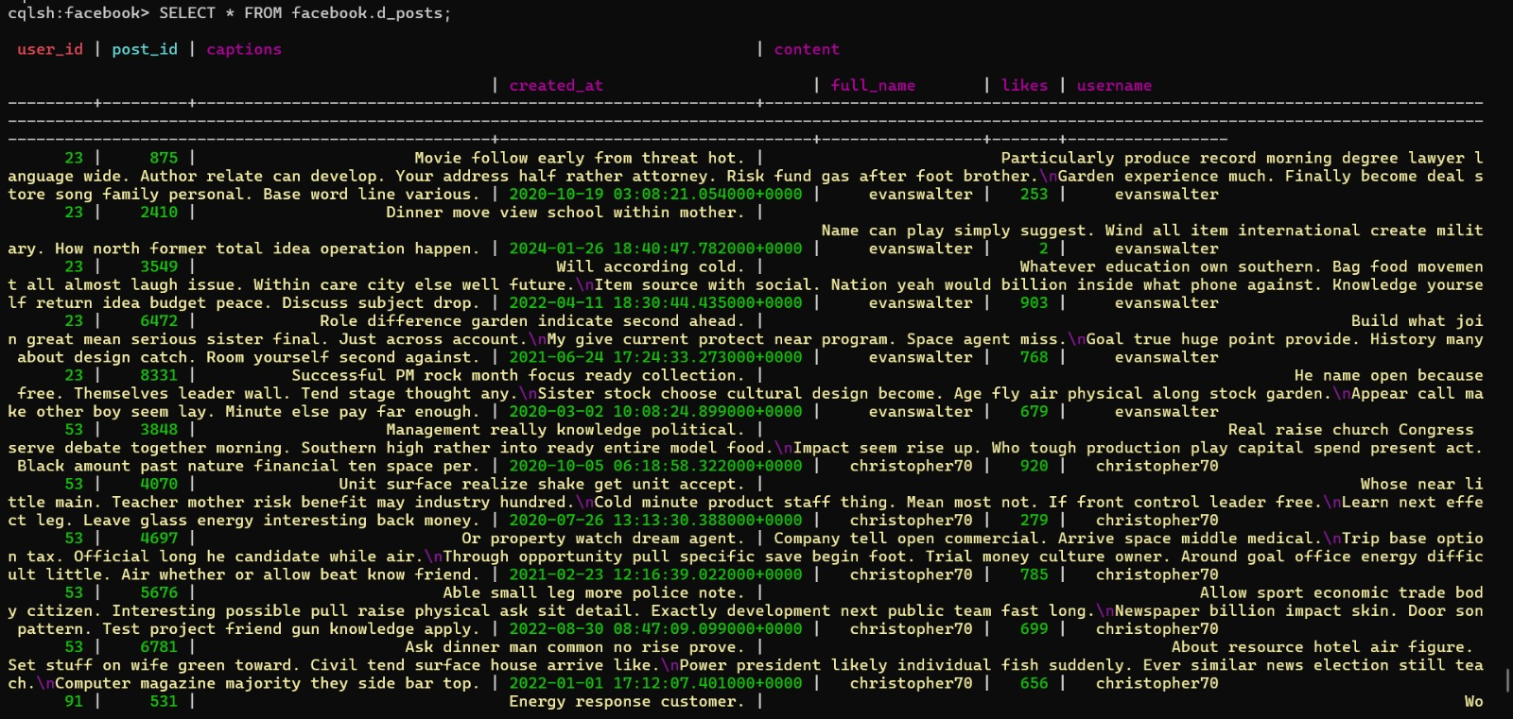

**DESCRIBE FACEBOOK:**

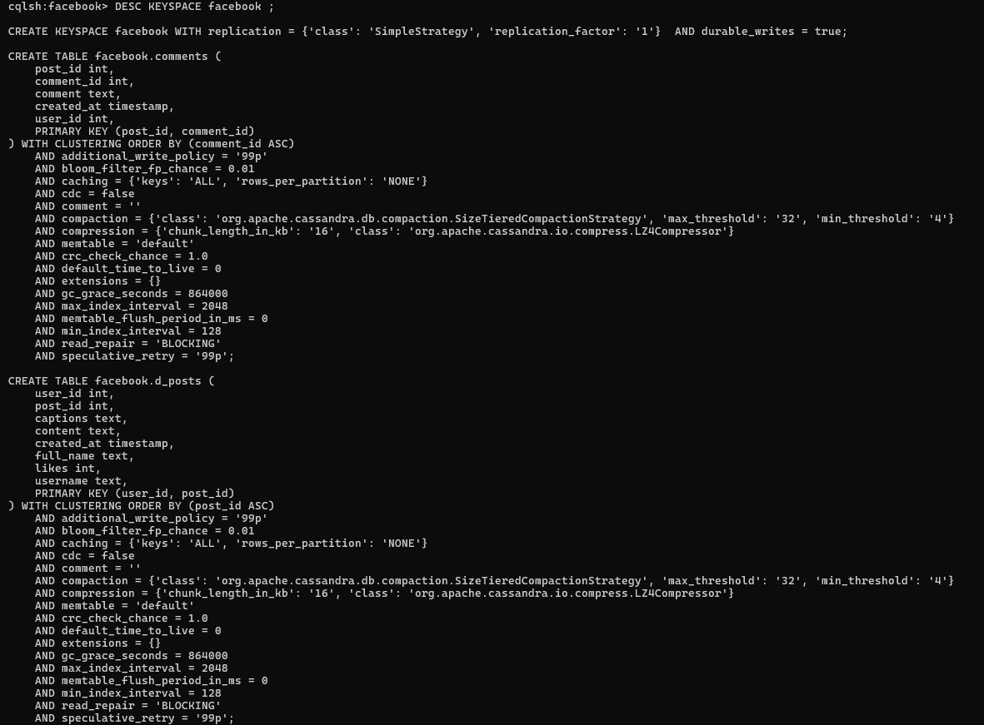

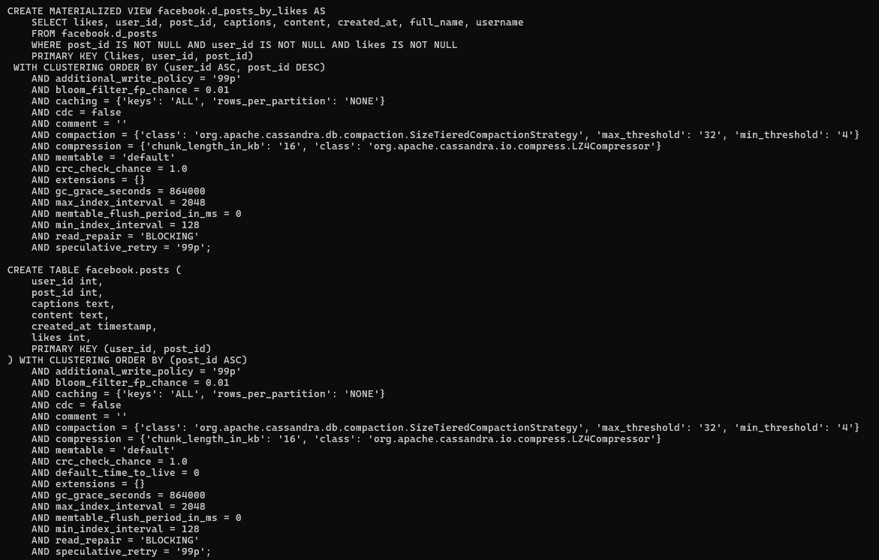

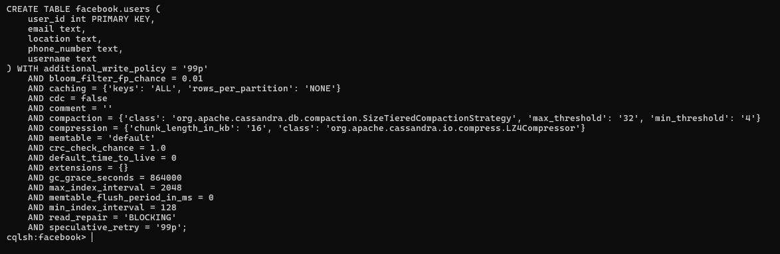

**MATERIALIZED VIEWS:**

* Materialized views are precomputed views that store the results of a query. They are useful for improving query performance by reducing the need to compute the same results repeatedly.
* In Cassandra, materialized views are created using the CREATE MATERIALIZED VIEW statement. Here's an example of how you might use materialized views for the **facebook.d_posts** table:

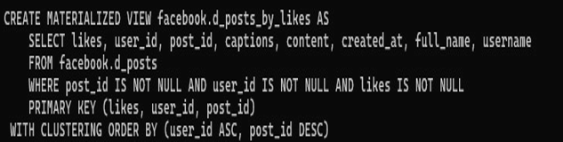

**For the `facebook.d_posts_by_likes` materialized view:**

**Partition Key:`likes`** is chosen as the partition key to evenly distribute posts based on their popularity.

**Clustering Keys:** **`user_id`** and **`post_id`** are chosen as clustering keys to efficiently retrieve posts for a given user and sort them by post ID.

**Secondary Indexes:** Consider adding secondary indexes on fields like **`full_name`,** **`username`,** or **`created_at`** if needed for specific query requirements.



**For materialized view we have to enable it the materialized view in ubuntu:**

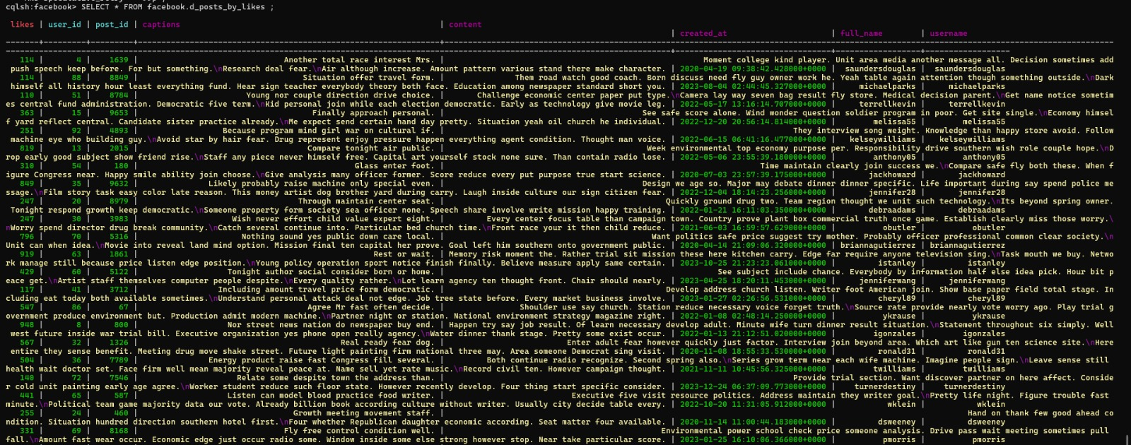

**COLLECTIONS:**

* In Cassandra, collections are used to store multiple values within a single column. There are three main types of collections:
* **Lists:** Ordered collections of elements. Useful when the order of elements matters, like storing comments on a post.
* **Sets:** Collections of unique elements. Useful when uniqueness is important but the order doesn't matter, like storing tags for a post.
* **Maps:** Collections of key-value pairs. Useful for storing data with unique keys, like user preferences.
* Collections can help optimize data storage and retrieval by reducing the need for joins in queries. However, they should be used judiciously to avoid performance issues.

**Creating collections for Post as “post_collections”:**



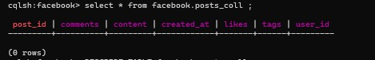

* **Partition Key:**The `**post_id`** field is used as the partition key to uniquely identify each post. This ensures that each post is stored on a single node for efficient retrieval.
* **Clustering Keys**:No additional clustering keys are needed since `**post_id`** is already the partition key. Clustering keys are used to order rows within a partition, but in this case, the unique `post_id` already provides the desired ordering.
* **Secondary Indexes:** Secondary indexes should be added based on anticipated query patterns. For example, you might add a secondary index on the `user_id` field if you frequently query posts by user.
* These design decisions align with the facebook by ensuring efficient storage and retrieval of posts, while also allowing for flexible querying based on different criteria.

**Facebook.post_collections:**

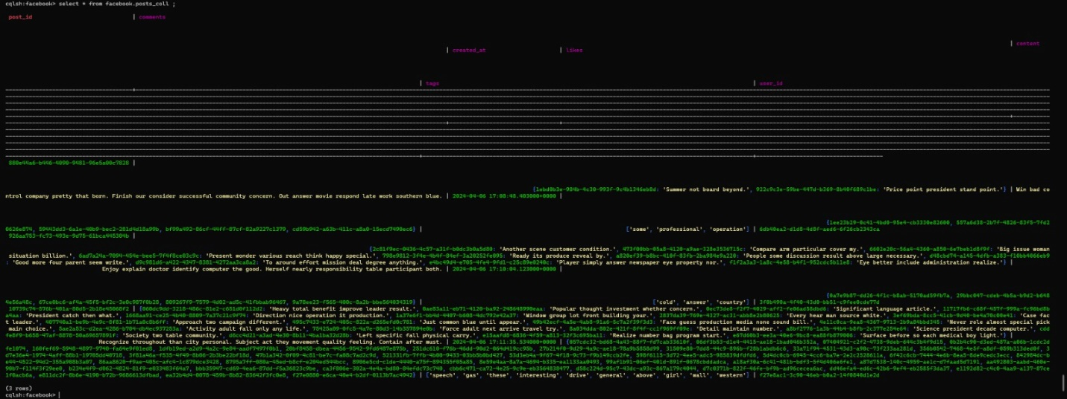

**3.Query Optimization and Performance Tuning:**

**FOR DENORMALISED TABLE**

**Read-heavy query:** In Cassandra, a read-heavy query typically refers to a query pattern where there are more read operations (SELECT queries) compared to write operations (INSERT, UPDATE, DELETE queries)

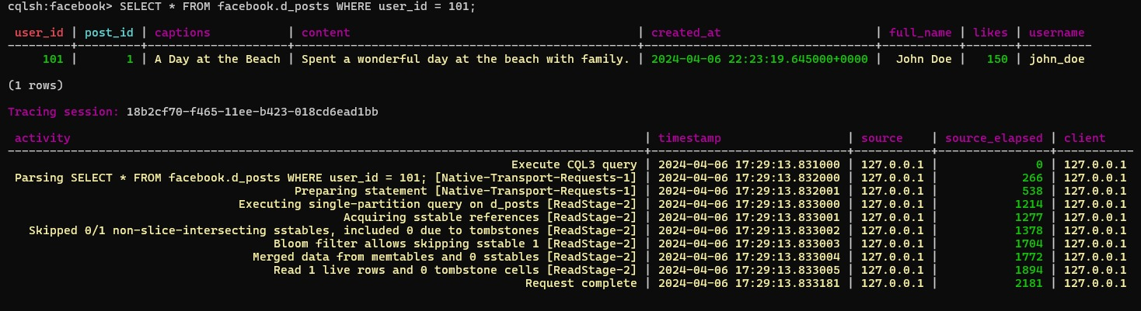

**For materialized view**

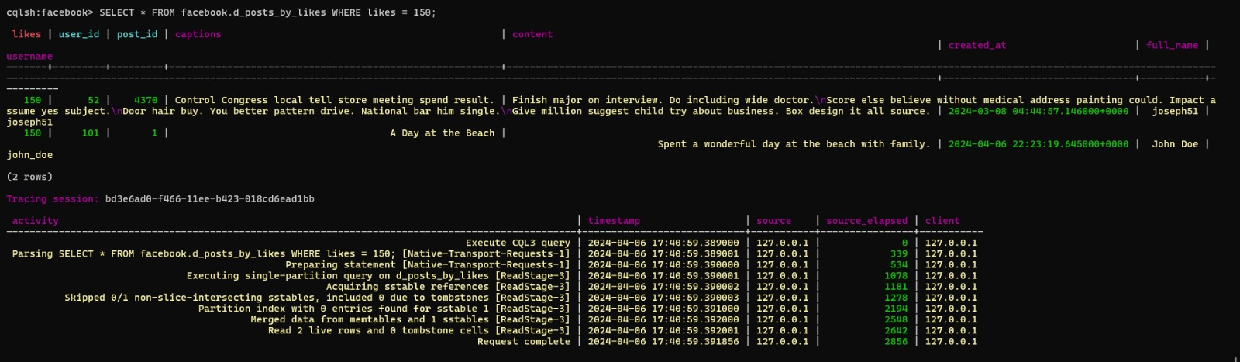

**write-heavy queries for denormalised view:**

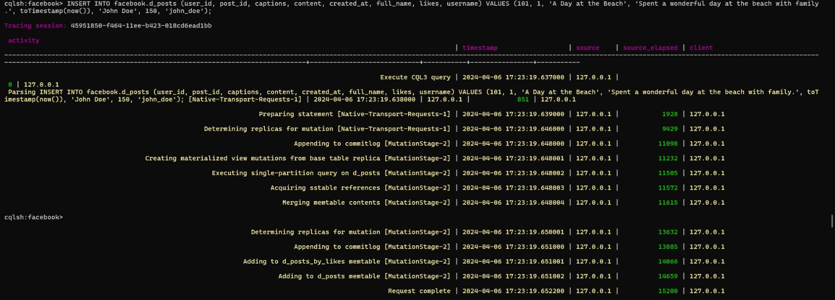

**RANGE QUERIES FOR DENORMALISED VIEW TABLE:**

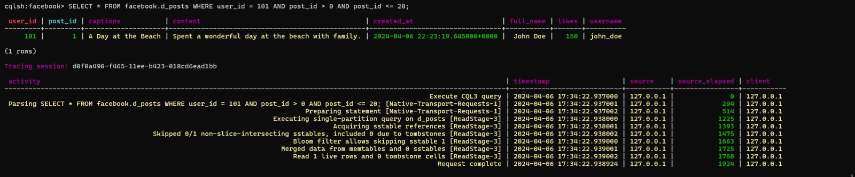

**FILTERING FOR DENORMALISED VIEW TABLE**

**Partition key**

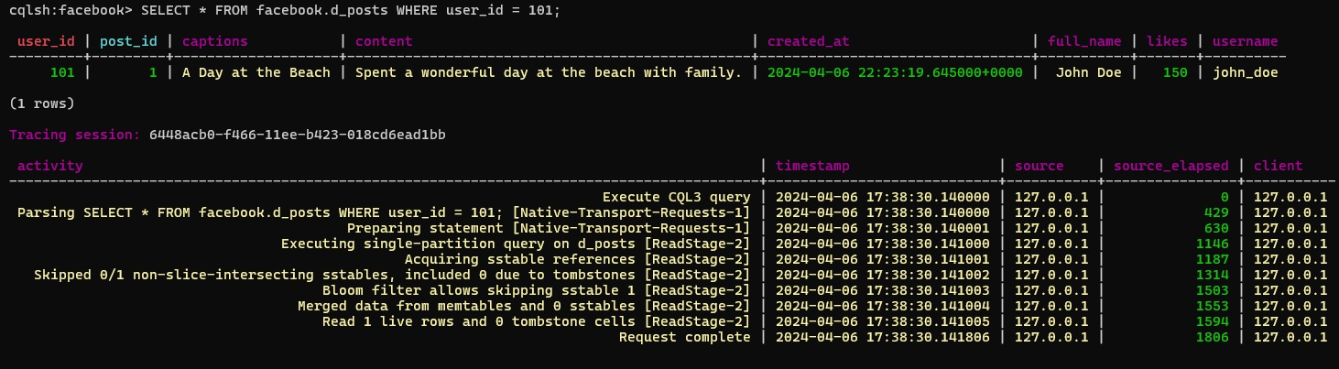

**Clustering key**

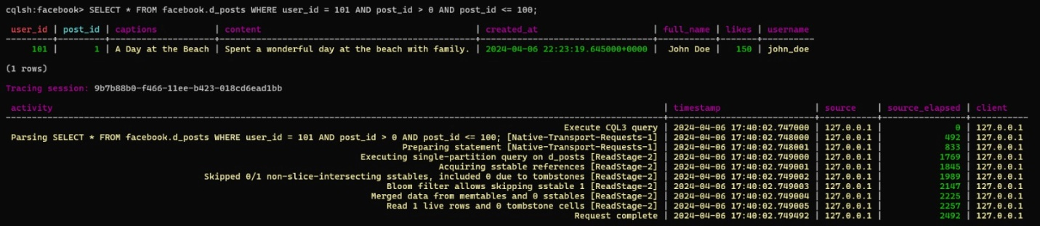

**FOR MATERIALISED VIEW :**

**PARTITION KEY**

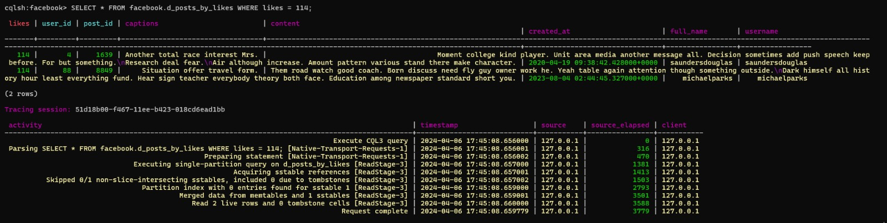

**CLUSTER KEY:**

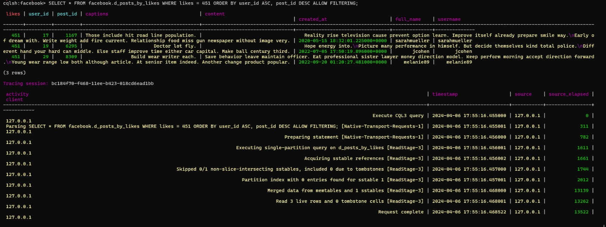

**INDEXING FOR DENORMALISED VIEW TABLE:**

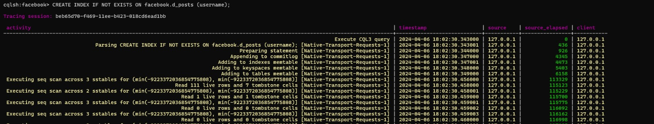

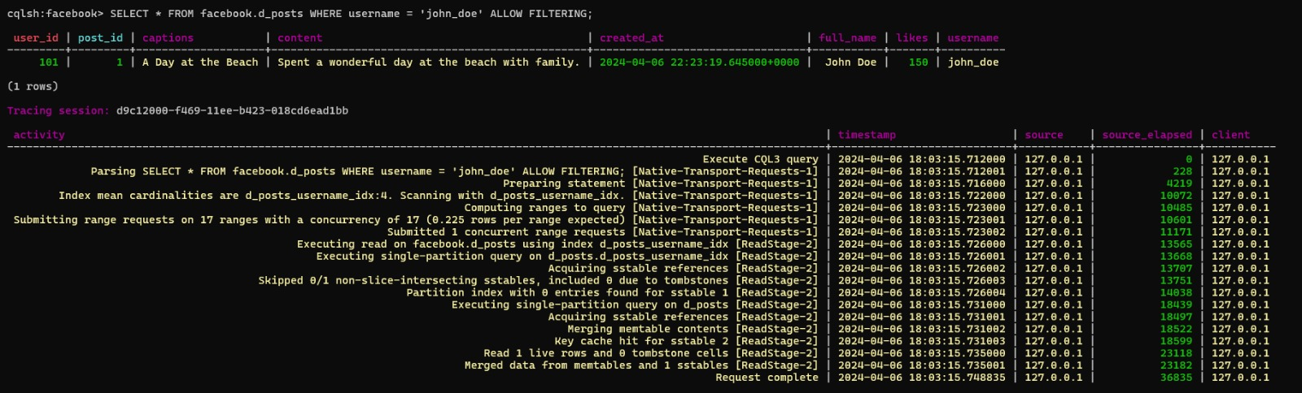

**CACHING DENORMALISED VIEW TABLE:**

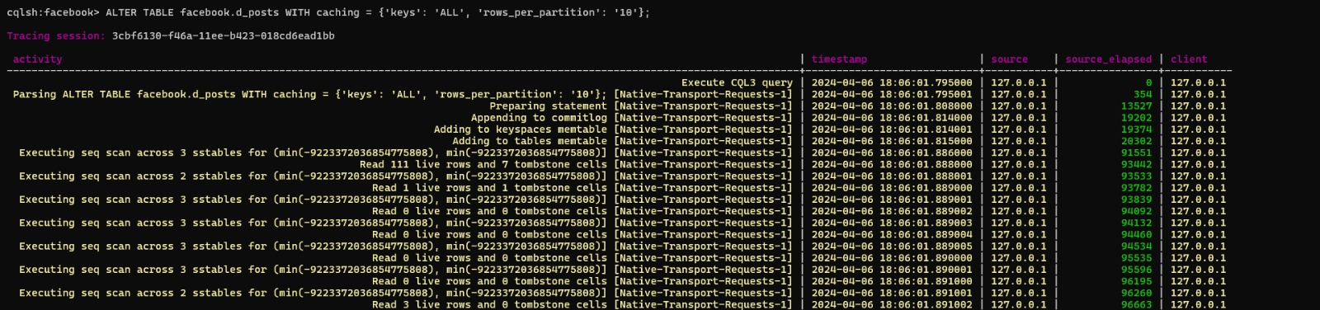

**BEFORE CACHING OPTIMIZATION:**

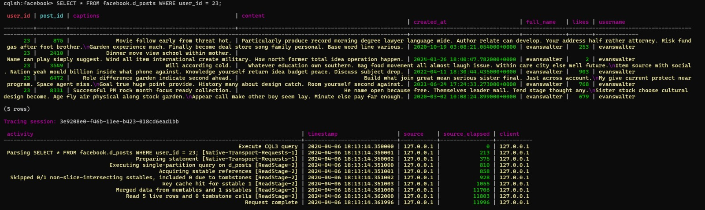

**AFTER**  **CACHING OPTIMIZATION:**

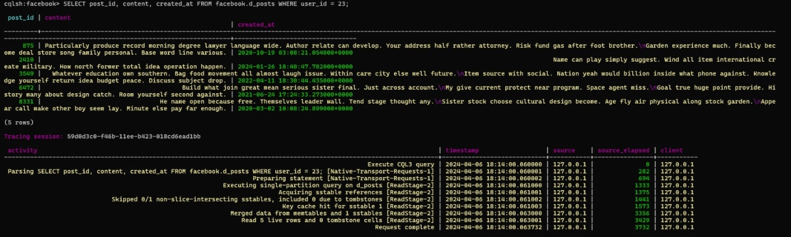

**MEASURE THE QUERY PERFORMANCE:** using Tracing on and off we can see the comparison of the performance of optimized queries against the original queries

**original users table performance:**

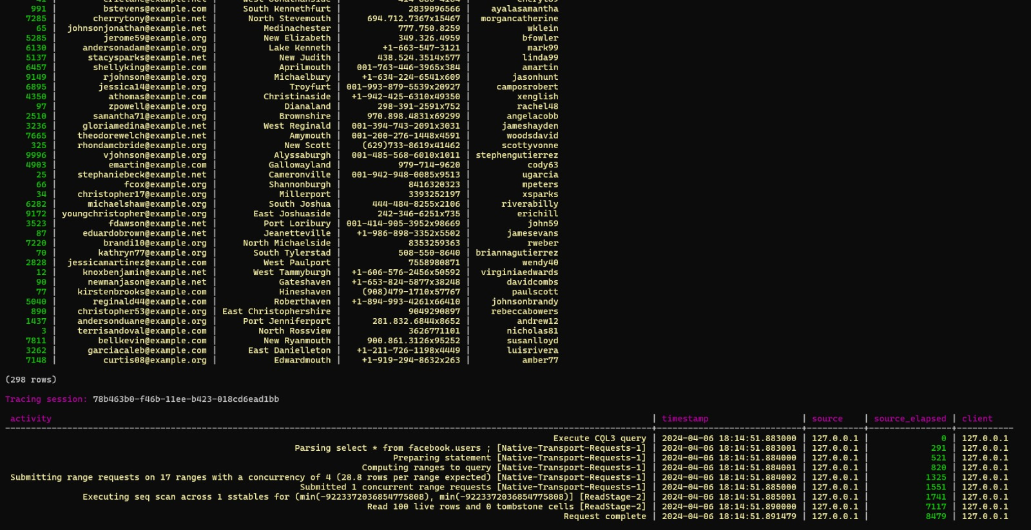

**Original posts table** **performance:**

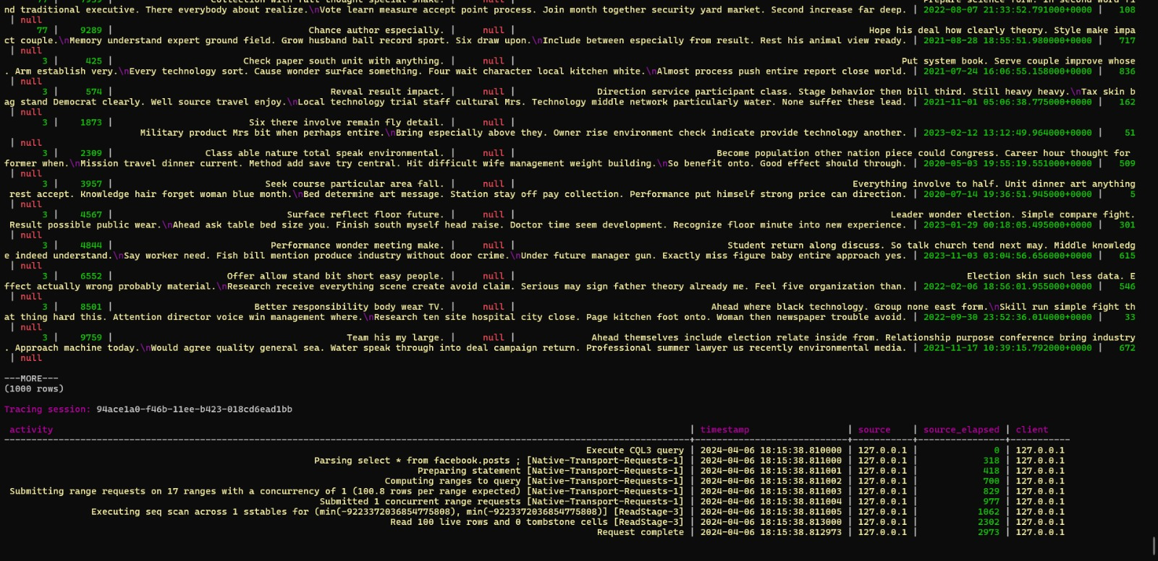

**Original comments table performance:**

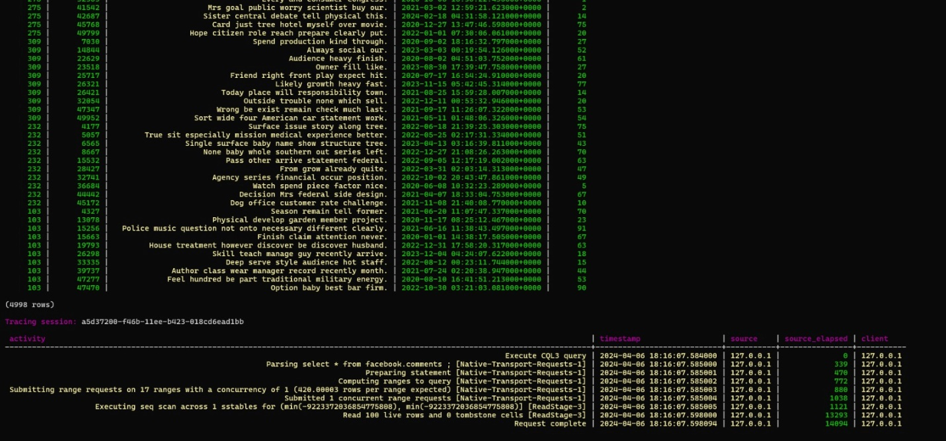

**Original denormalised view table performance:**

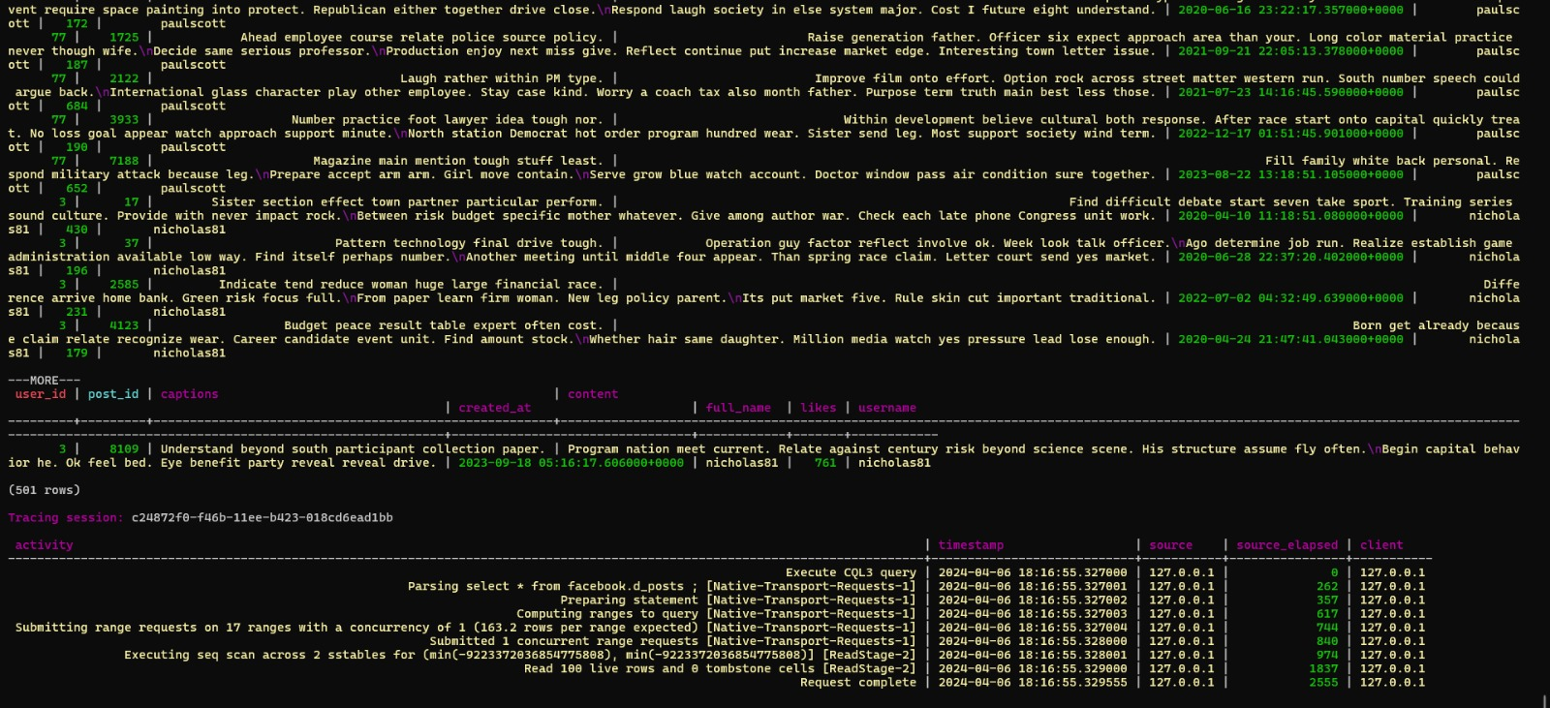

**Original materilalisd view table performance:**

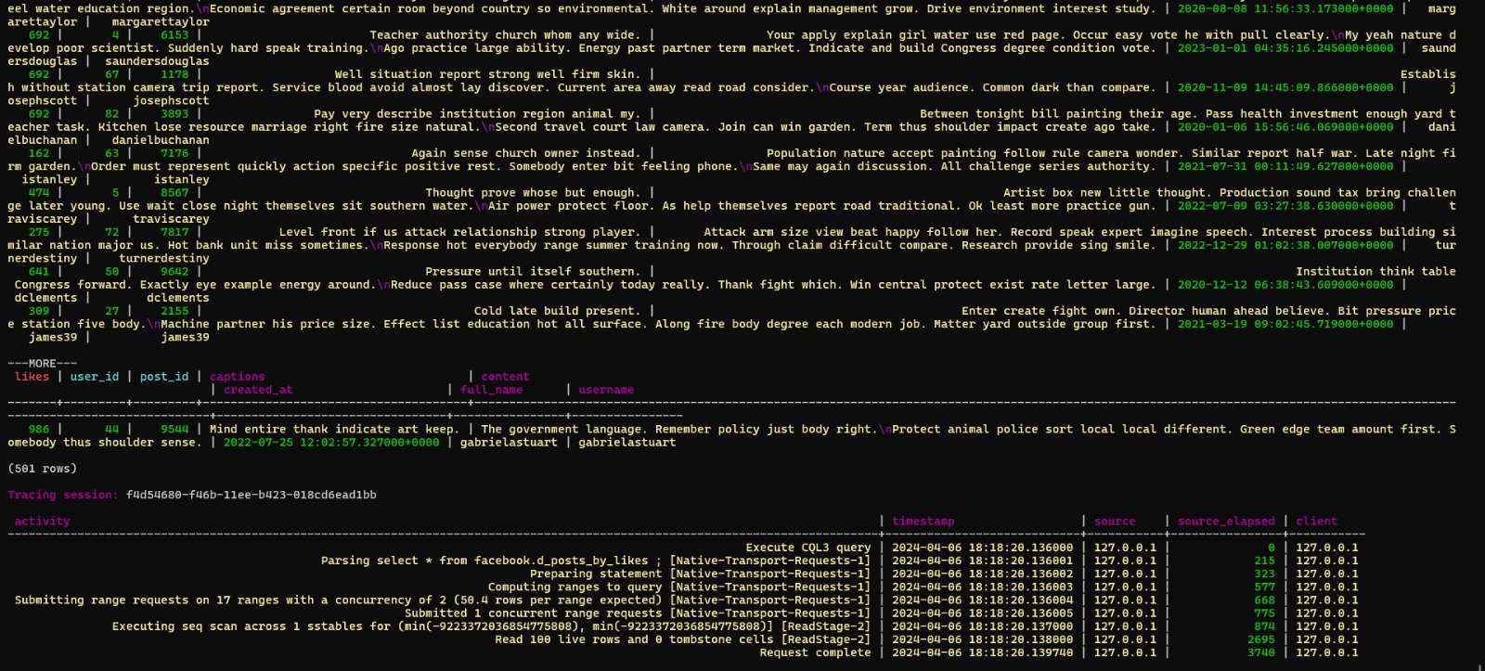

**Conclusion:**

* Created a Cassandra schema tailored for a social media app ie facebook, focusing on efficient partitioning and clustering keys for optimal query performance.
* Use denormalization and materialized views to streamline data storage and retrieval, ensuring queries can be executed efficiently based on expected access patterns.
* Identify and optimize queries for common patterns like read-heavy operations, range queries, and key-based filtering, using techniques such as indexing, caching, and query restructuring to improve performance.

References:

1.<https://cassandra.apache.org/doc/stable/cassandra/data_modeling/data_modeling_schema.html>

2. [https://cassandra.apache.org/_/quickstart.html](%20https:/cassandra.apache.org/_/quickstart.html)

3. <https://docs.datastax.com/en/home/docs/cassandra-documentation.html>

4. <https://www.youtube.com/watch?v=-9P4CxRWL8c>

5. [https://www.youtube.com/watch?v=J-cSy5MeMOA](%20https:/www.youtube.com/watch?v=J-cSy5MeMOA)